**EEE361**

**ASSIGNMENT**

**SET-3**

1. A wave is given is air:

E = (8ay – 6az) Sin $\left(ωt-4y-3z\right)$ V/m impinges a dielectric half- space as shown in Fig. Below. Find:

a. The incident angle $θ_{i}$

b. The reflected and Transmitted E and H field

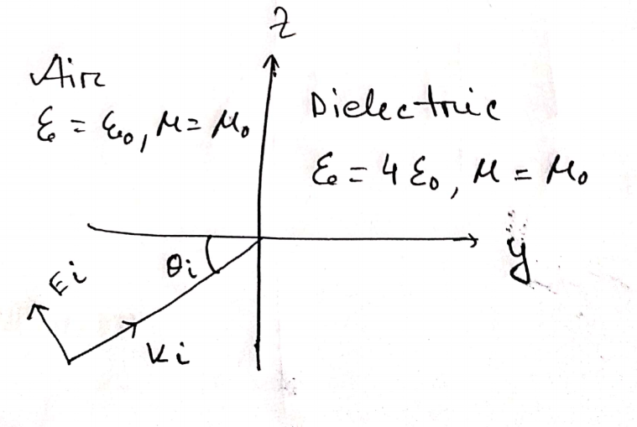

Fig: Problem 1

1. Show that

$$E_{x}(z,t) = F_{x }(t + \sqrt{με} z)$$

This expression satisfies the wave equation in a dielectric medium. Find the vector $\vec{H}$

1. (a) In free space, the electric filed is defined by

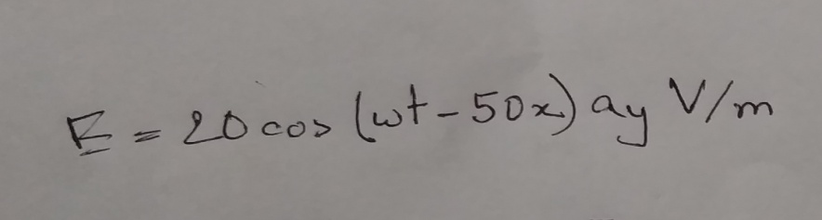

Using the knowledge of Maxwell’s equation calculate

* 1. Displacement current density, Jd
  2. Magnetic field intensity, H

(b) **(**i) We know that: Maxwell’s 4th law [known as Ampere’s law] has a quantity: electric conducting current. Now, explain**:** **why there is no magnetic conducting current** in the 3rd law of Maxwell’s Electromagnetic equation, known as Faraday’s law. Explain.

(ii) Why an Electromagnetic wave is expressed as a Cosine wave even though the electric and magnetic fields are round shaped closed lines. Please explain in detail.

1. For time varying fields: Find which if the following equations are not satisfy Maxwell’s Equation. Also state why the expression/s don’t satisfy Maxwell’s Equation? (Show Calculation)
$∇∙J + \frac{∂ρ_{v}}{∂t} = 0$

$∇∙D = ρ_{V}$

$∇∙ E = - \frac{∂B}{∂t}$

$\oint{H∙ dl} = \int{(σE + ε\frac{∂E}{∂t}} ) ∙ dS$

$\oint{B∙dS} = 0$

2. The integral

$$a=\int_{S}{da}$$

Is sometimes called the vector area of the surface S. If S happens to be flat then |a| is the scaler area, obviously.

a. Show that a = 0 for any closed surface.

b. show that a is the same for all surfaces sharing the same boundary.

c. Show that $a= \frac{1}{2} \oint{r × dl}$ where the integral is around the boundary line. [Hint: one way to do it is to draw the cone subtended by the loop at the origin. Divide the conical surface up into infinitesimal triangular wedges, each with vertex at the origin and opposite side **dl**, and exploit the geometrical interpretation of the cross product.